ADINA ISRAN
2303A52222 – 42

Web Frontend Development – AI-Assisted HTML/CSS/JS Generation
Task 1: Responsive Homepage Layout for a Startup Website
Scenario
You are designing a basic homepage for a startup company that needs
to look good on desktops, tablets, and mobile devices.
Task Description
• Create a web page structure using HTML that includes:
o A header with navigation links
o A main content section
o A footer with basic information
• Use AI assistance to generate responsive CSS using media
queries.
• Ensure the layout adjusts smoothly across different screen sizes.
Expected Output
• A responsive web page where:
o Header, content, and footer are clearly separated
o Layout adapts correctly to mobile, tablet, and desktop
views
o Code is clean and well-structured

PROMPT:
Create a basic homepage for a startup company that needs to look good on desktops, tablets, and mobile devices. using HTML that includes header with navigation links, main content section,footer with basic information. Generate responsive CSS using media queries. Ensure the layout adjusts smoothly across different screen sizes.

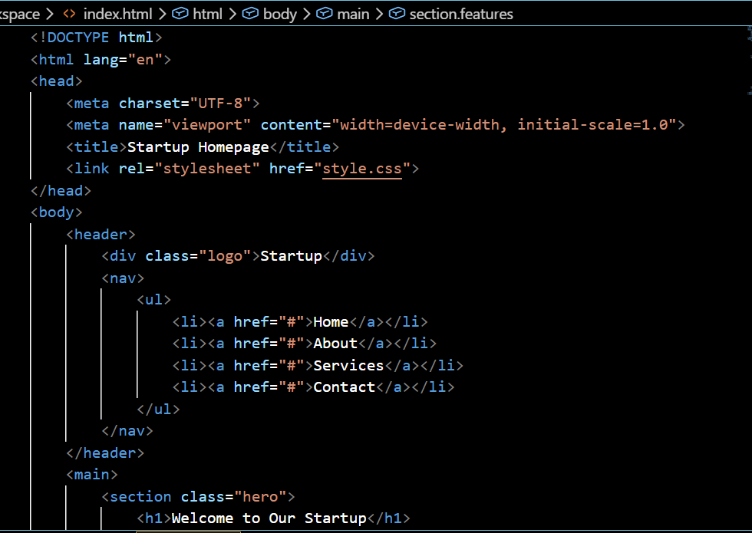
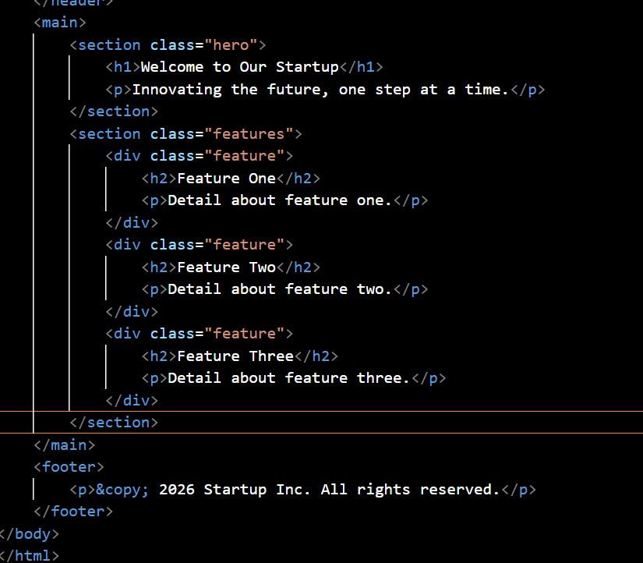
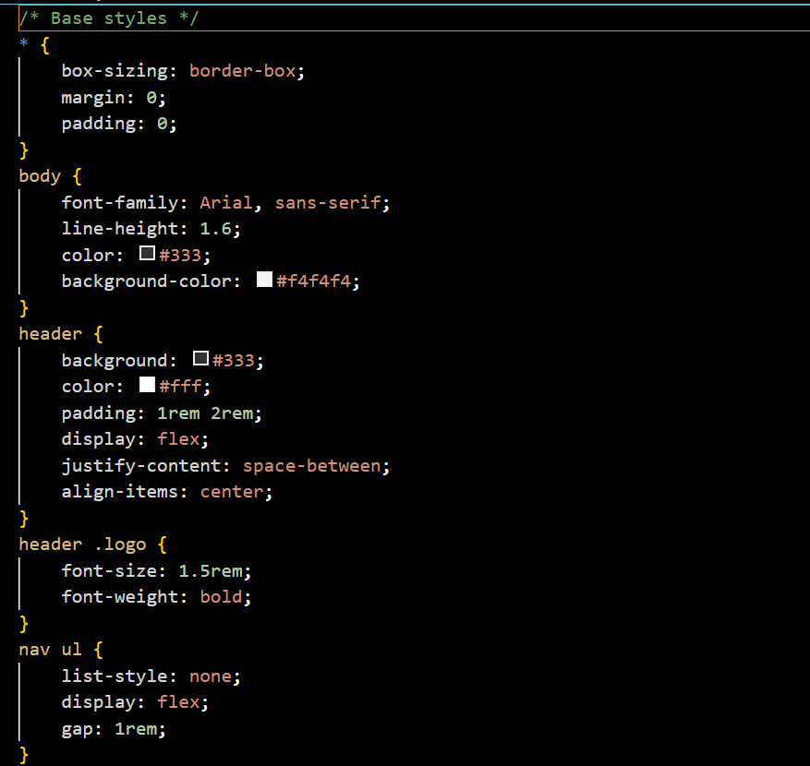
OUTPUT:
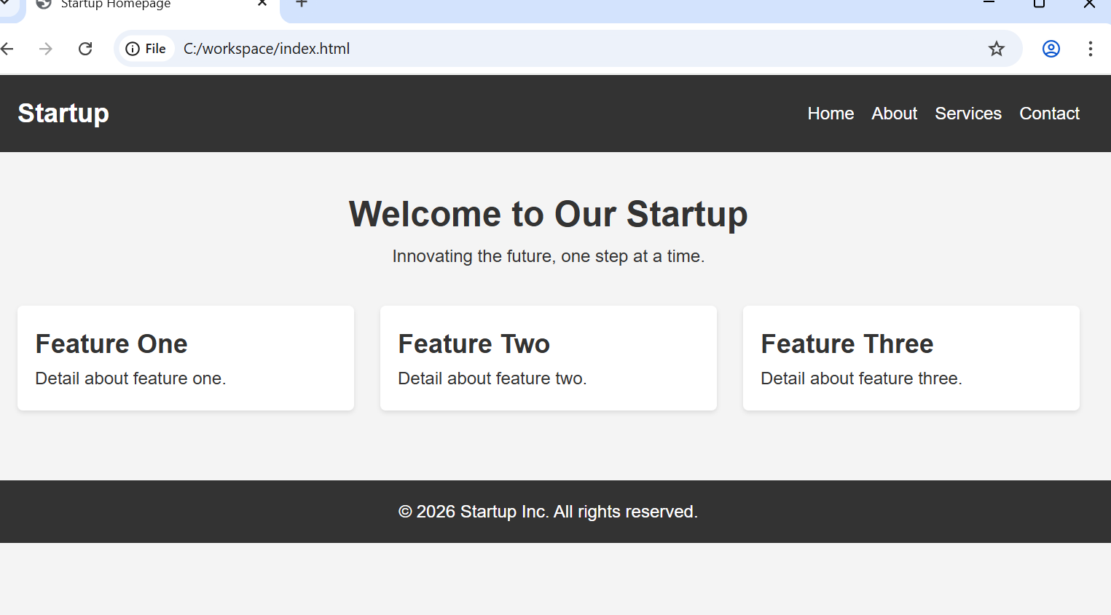

JUSTIFICATION:
The goal was to ensure the website remains functional and readable across all devices. By using a mobile-first approach with CSS Flexbox and media queries, the layout automatically adjusts from a wide desktop view to a stacked vertical view on smartphones, providing a seamless user experience regardless of screen size.

Task 2: Interactive Call-to-Action Button
Scenario
A marketing page requires a call-to-action button that responds when
users interact with it.
Task Description
• Add a button to a web page using HTML.
• Use AI to generate JavaScript that responds to the button click
by:
o Displaying a message or alert
• Ask AI to add meaningful comments explaining the JavaScript
logic.
Expected Output
• A web page where:
o Clicking the button triggers a visible response (alert or
message)
o JavaScript code is readable and commented
o No page reload occurs

PROMPT:
"Generate an HTML contact form. Write JavaScript code to prevent submission if fields are empty or if the email address is invalid. Show red error messages below the input fields."

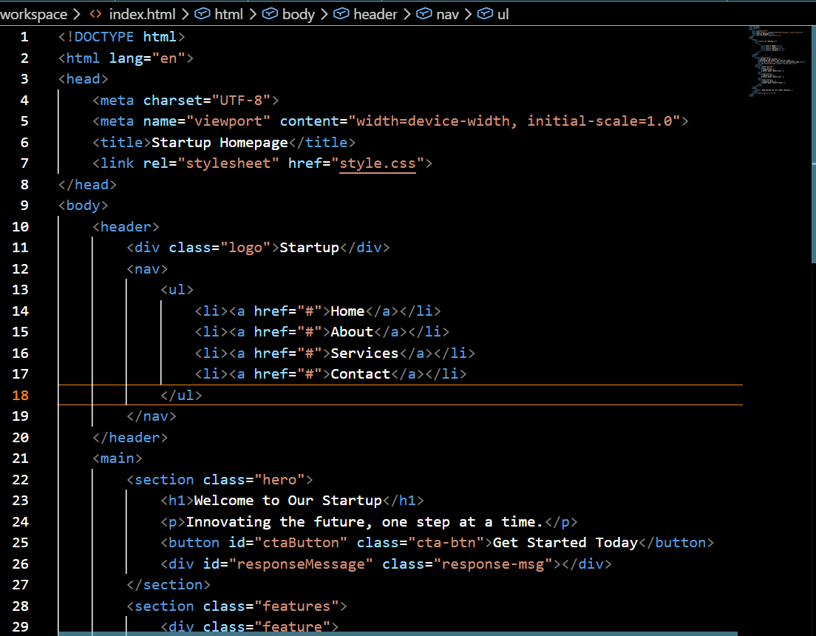
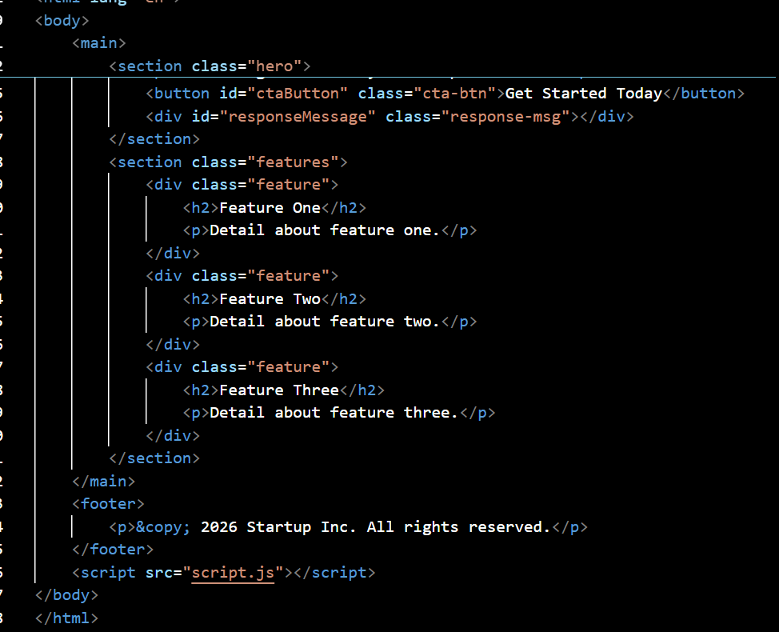
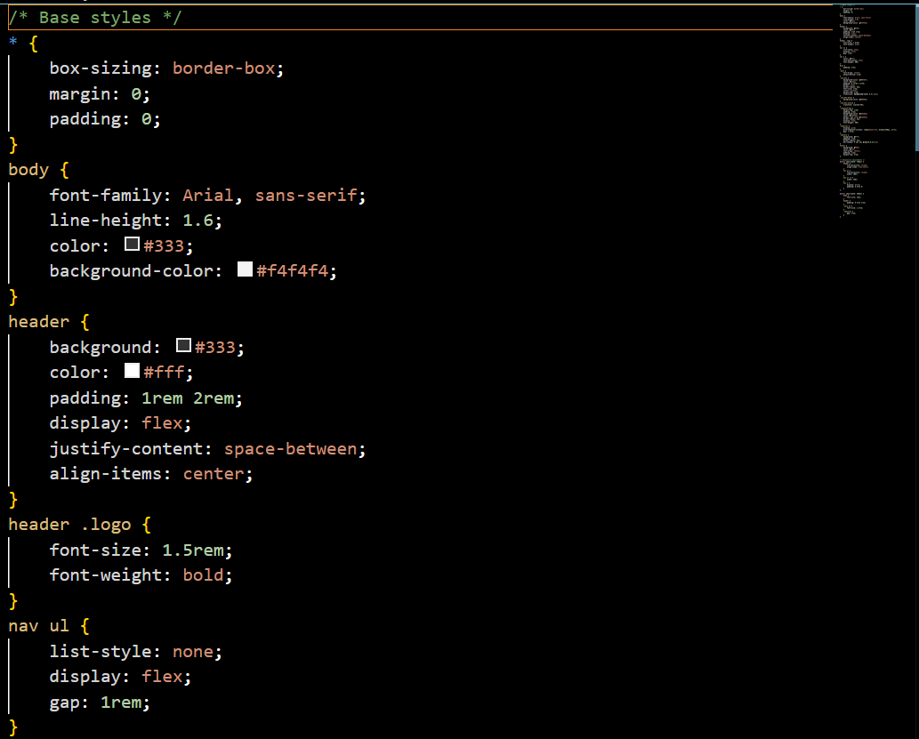
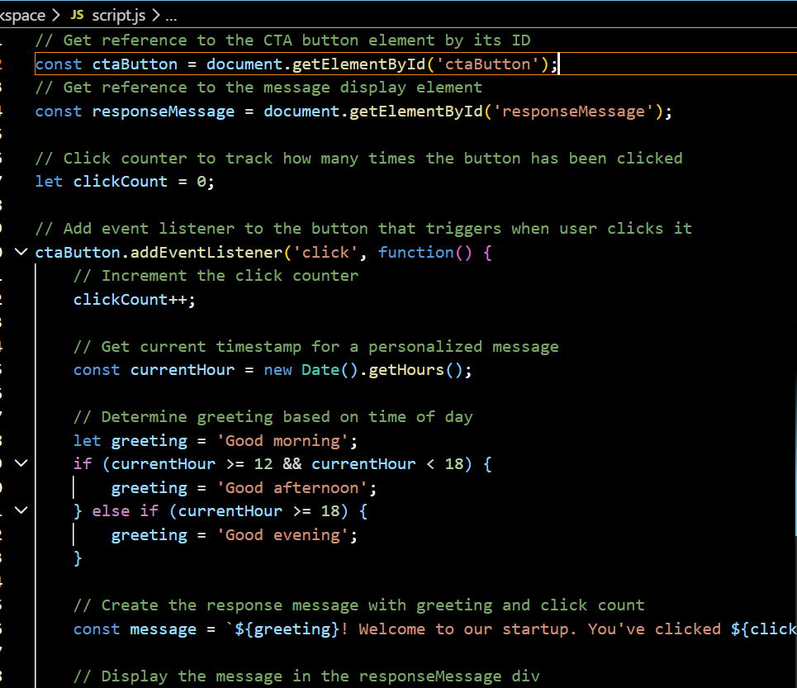
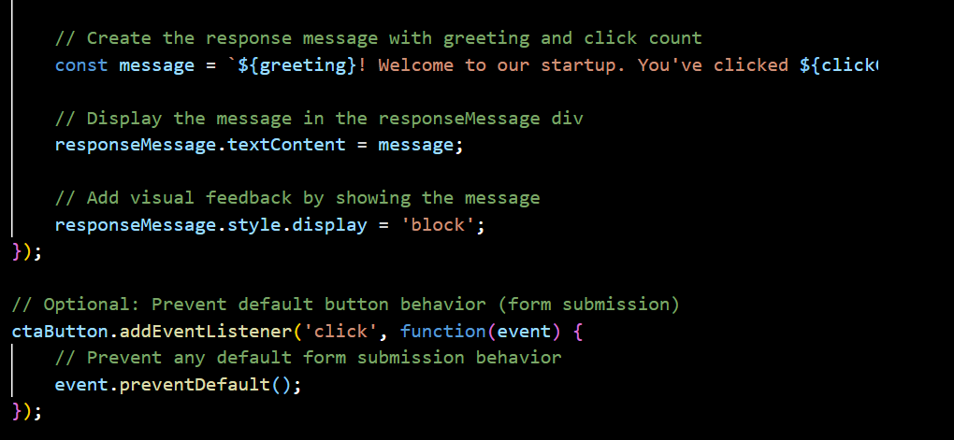

OUTPUT:
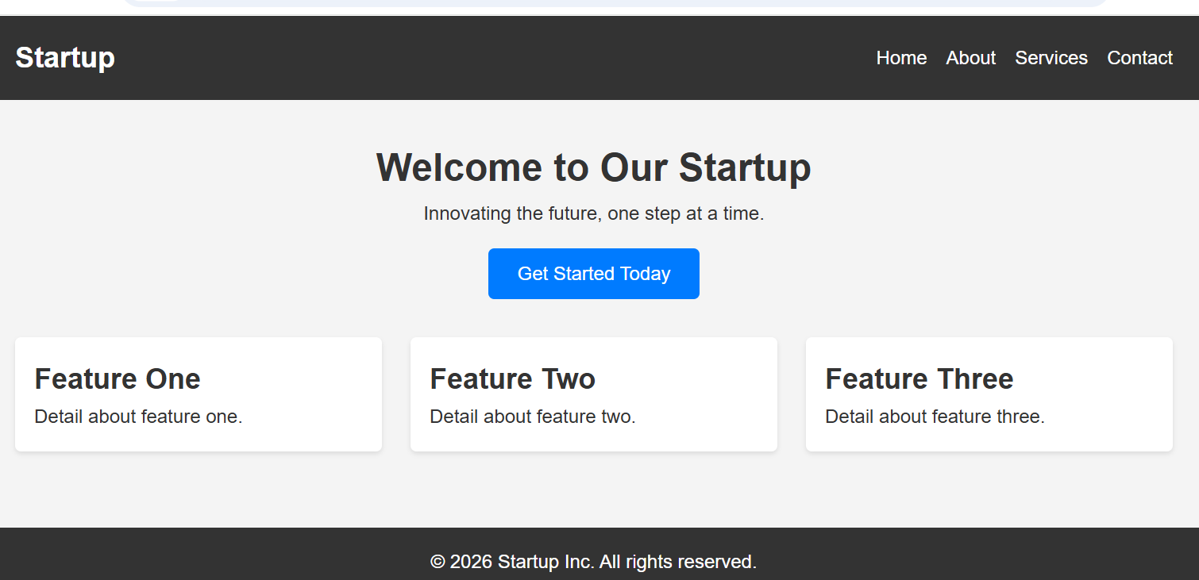
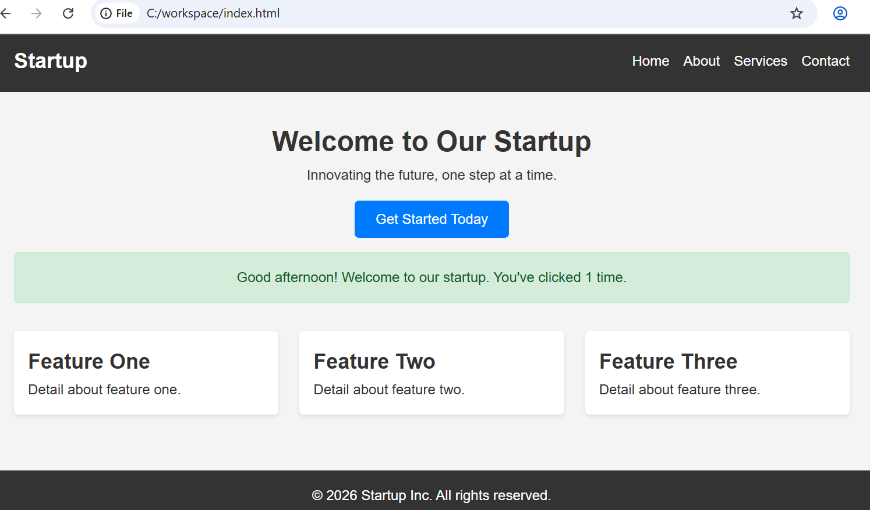
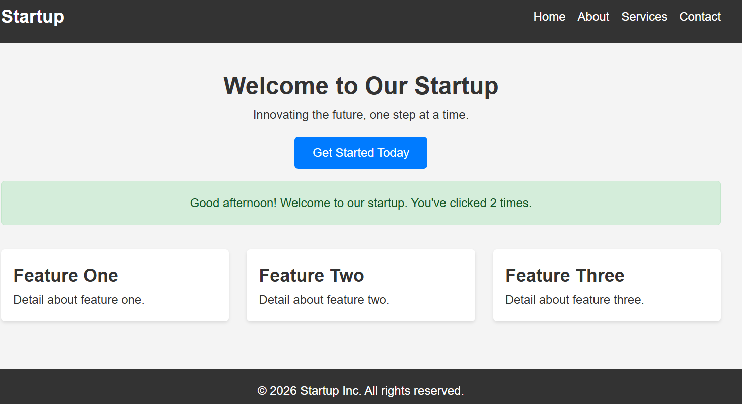
JUSTIFICATION:
This task focuses on basic user engagement by making a static button functional. By attaching a JavaScript event listener, we bridge the gap between UI design and logic, ensuring that the system acknowledges a user's intent (the click) with an immediate, clear response (the alert).

Task 3: Contact Form with Client-Side Validation
Scenario
You are developing a contact form for a company website to collect
user queries safely and correctly.
Task Description
• Design a form with fields for:
o Name
o Email
o Message
• Use AI to generate JavaScript validation logic that:
o Prevents empty submissions
o Checks for a valid email format
• Display clear error messages for invalid input.
Expected Output
• A functional form where:
o Invalid input shows inline error messages
o Valid input displays a success message
o Validation happens on the client side using JavaScript

PROMPT:
AI Prompt: "Generate an HTML contact form. Write JavaScript code to prevent submission if fields are empty or if the email address is invalid. Show red error messages below the input fields."

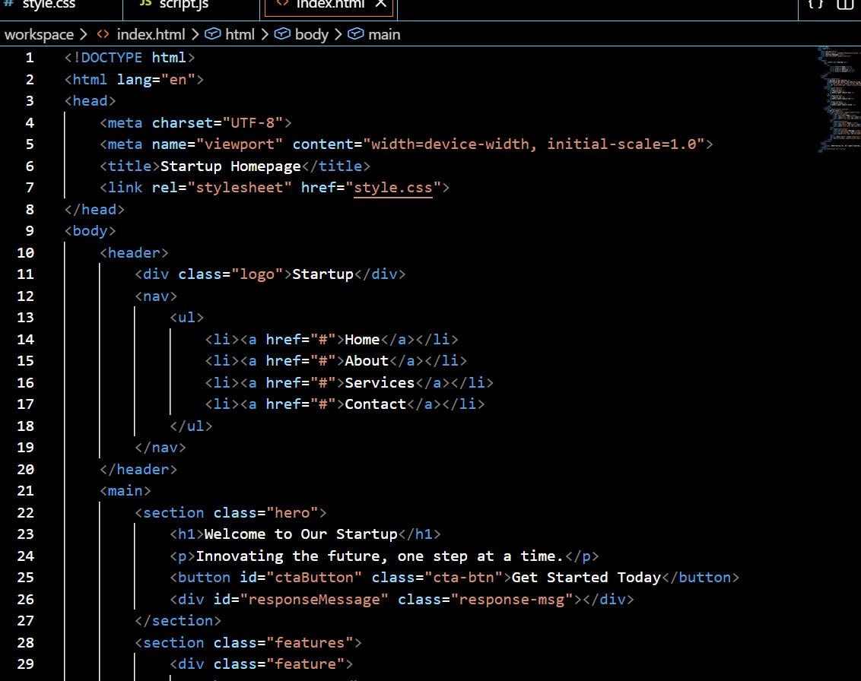
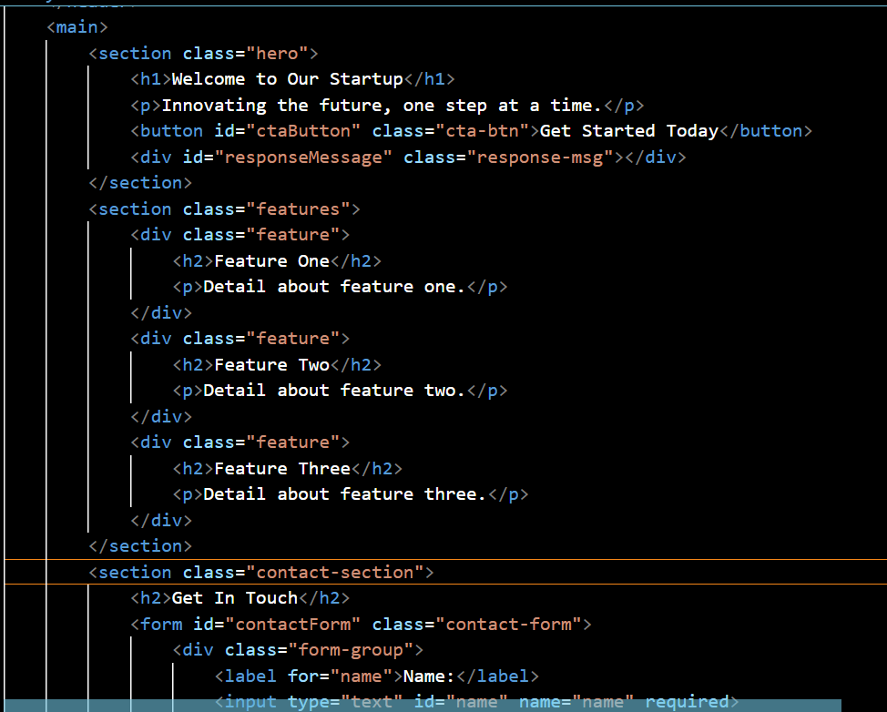
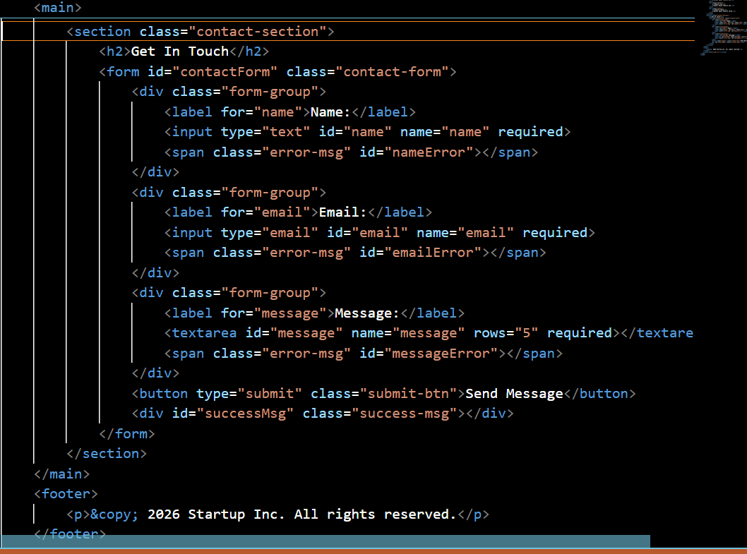
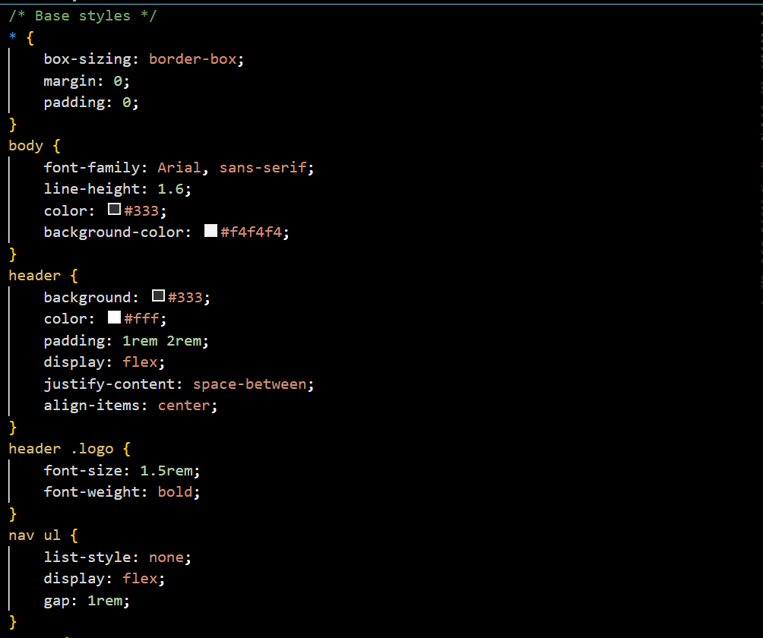
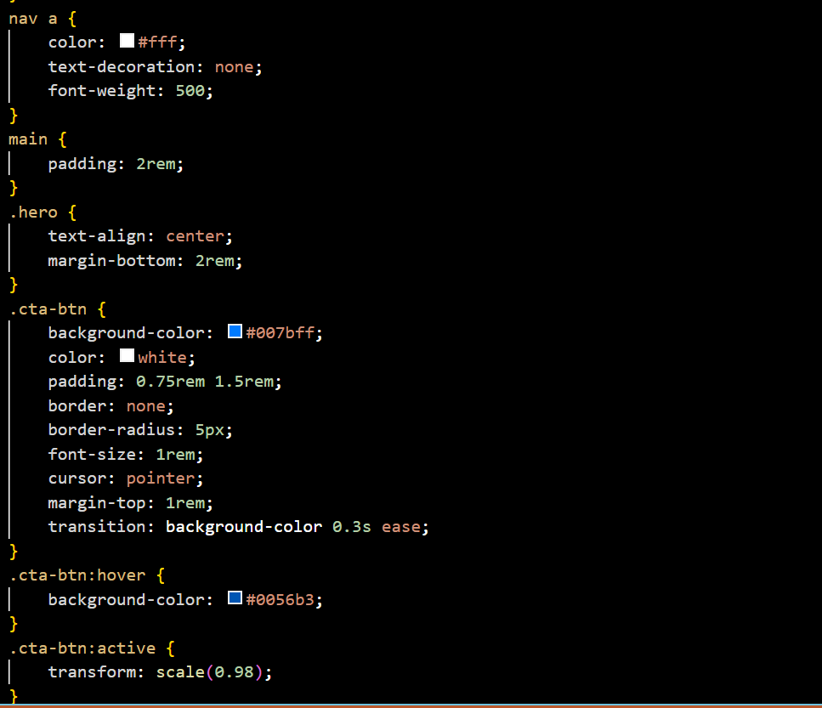
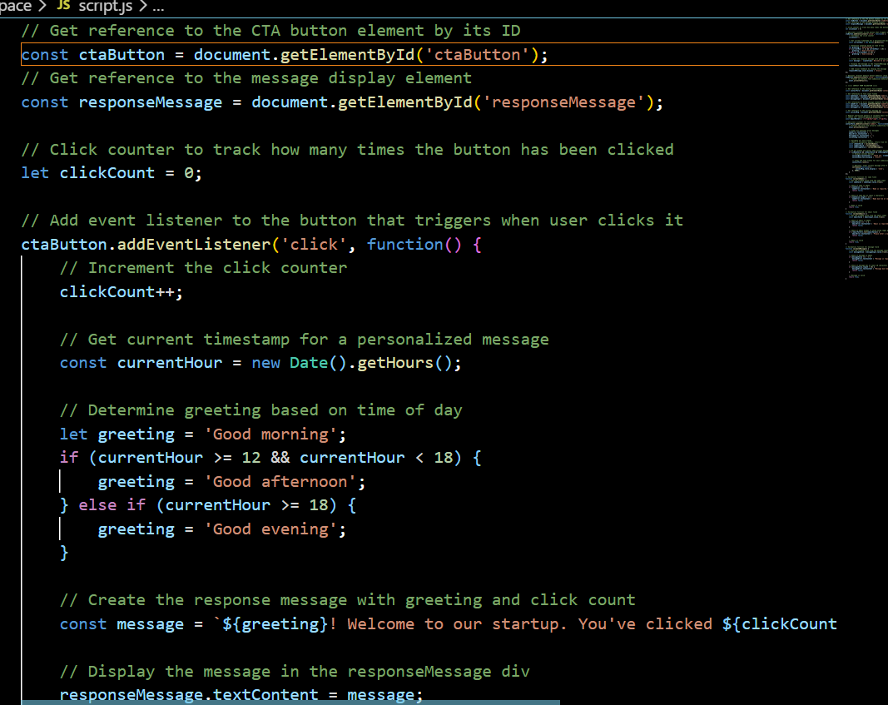
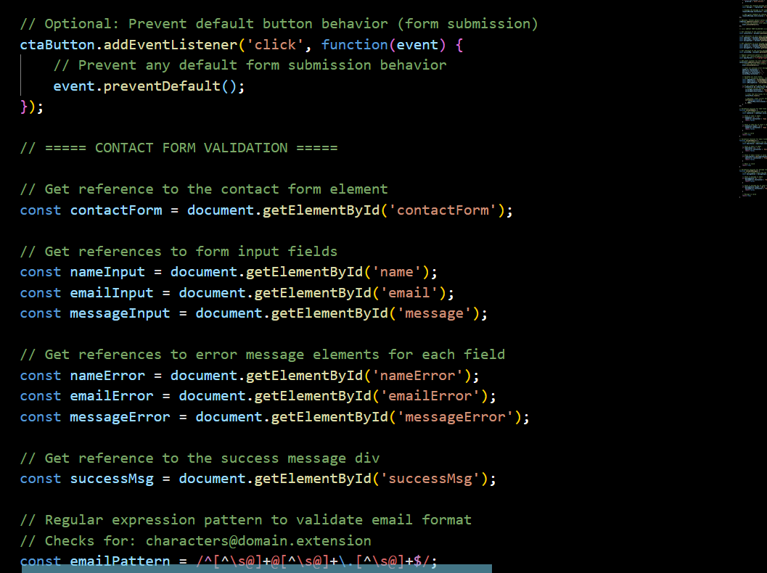
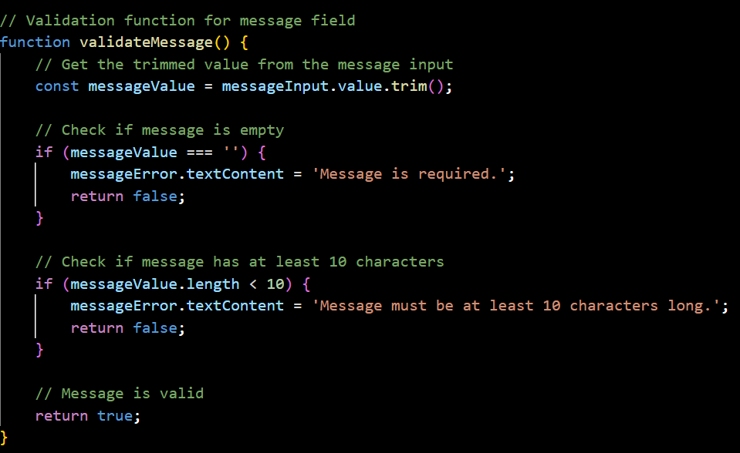
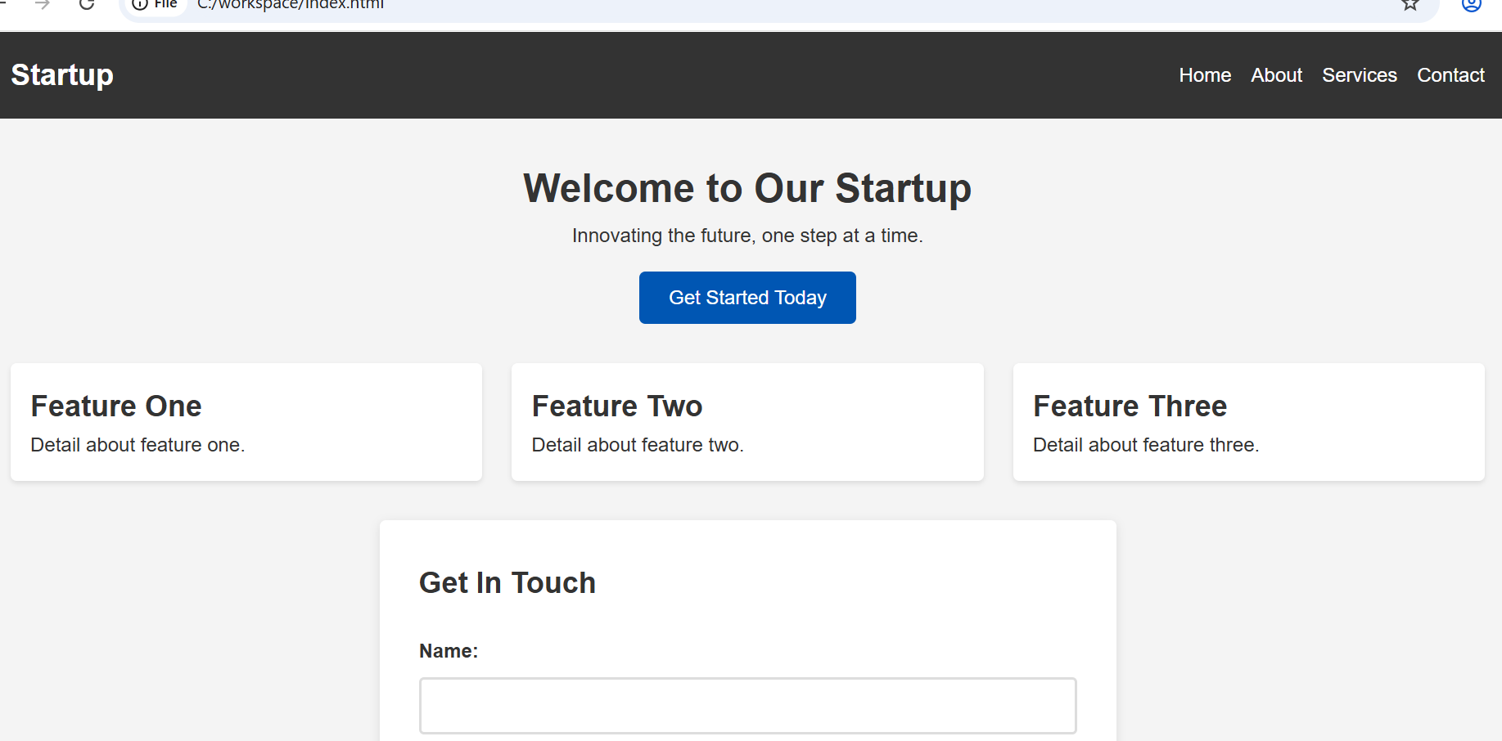
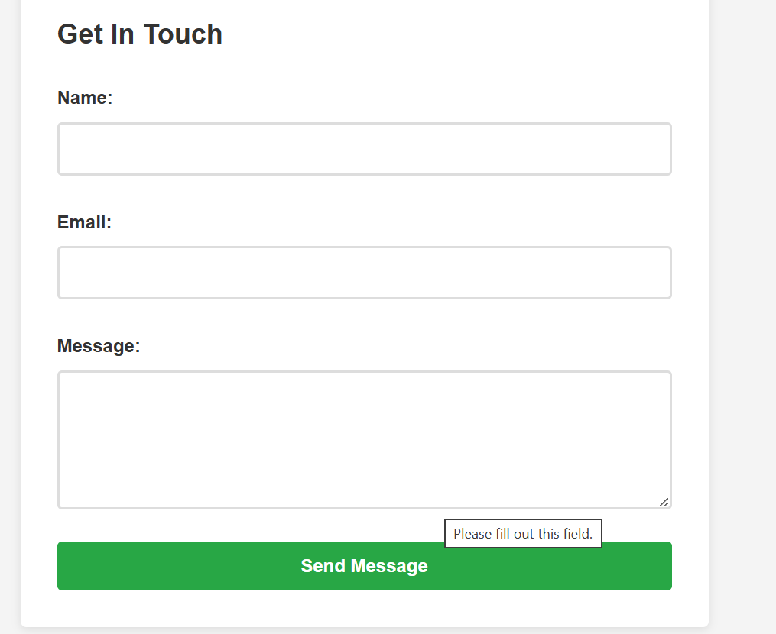

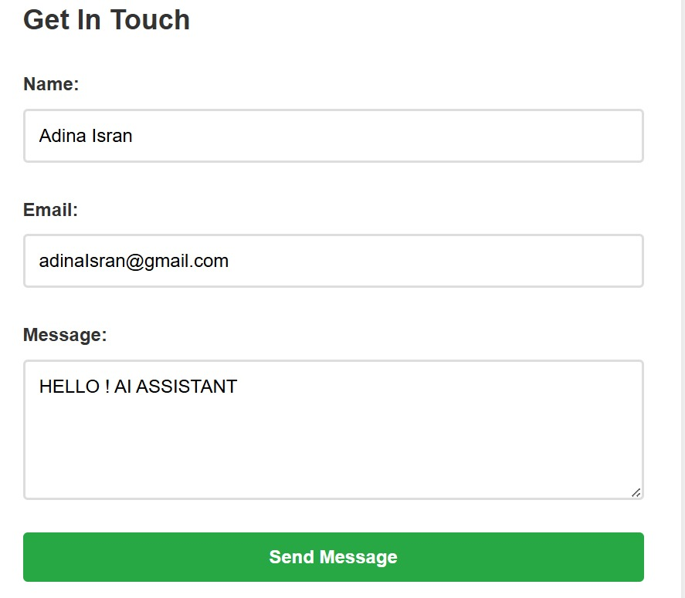

JUSTIFICATION:
Validation is essential for data integrity and reducing server-side errors. By using JavaScript and Regular Expressions, we provide instant feedback to the user if they make a mistake, ensuring that only correctly formatted information is processed while keeping the interface intuitive and helpful.

Task 4: Dynamic List Management for a Product Page
Scenario
A product listing page needs to add or remove items dynamically
without refreshing the page.
Task Description
• Create a simple HTML list to display items.
• Use AI to generate JavaScript that:
o Adds a new item when an “Add” button is clicked
o Removes the last item when a “Remove” button is clicked
• Ensure the DOM updates dynamically.
Expected Output
• A web page where:
o Items can be added and removed dynamically
o Changes appear instantly without page reload
o JavaScript logic is clear and maintainable

PROMPT:
"Write HTML and JS to manage a list. Include an input field and 'Add' button to append new items to the list, and a 'Remove' button that deletes the last item added."

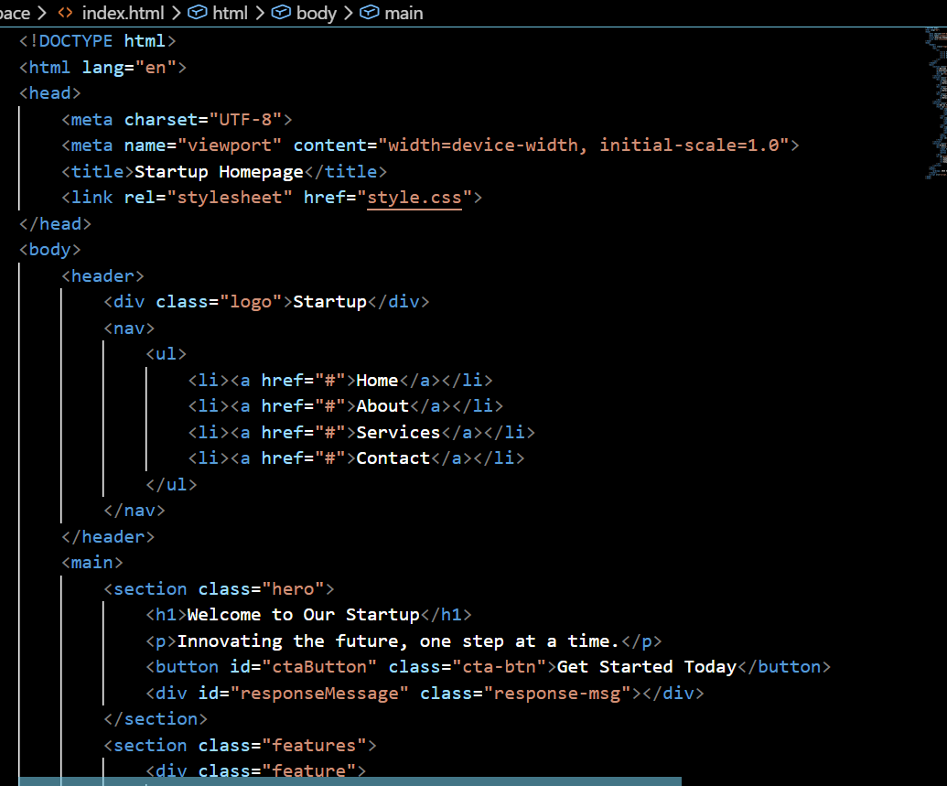
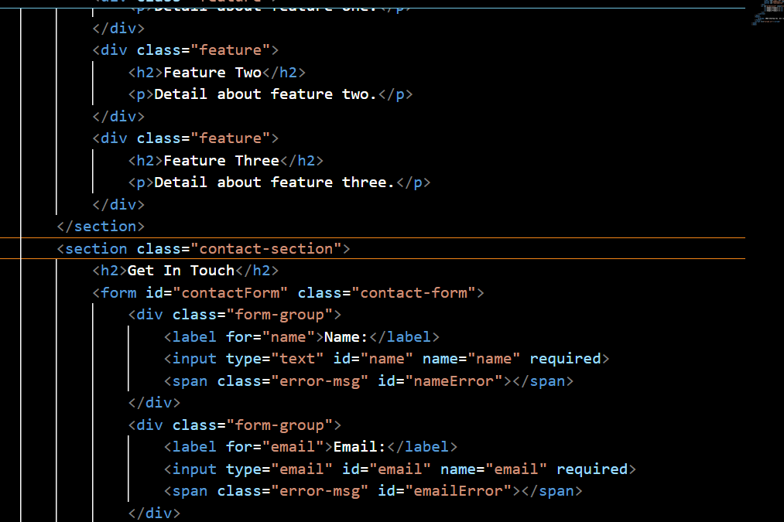
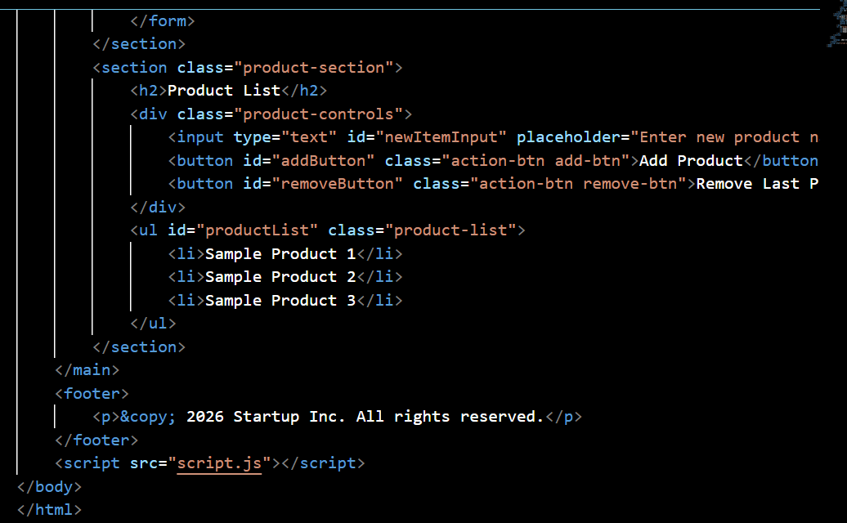
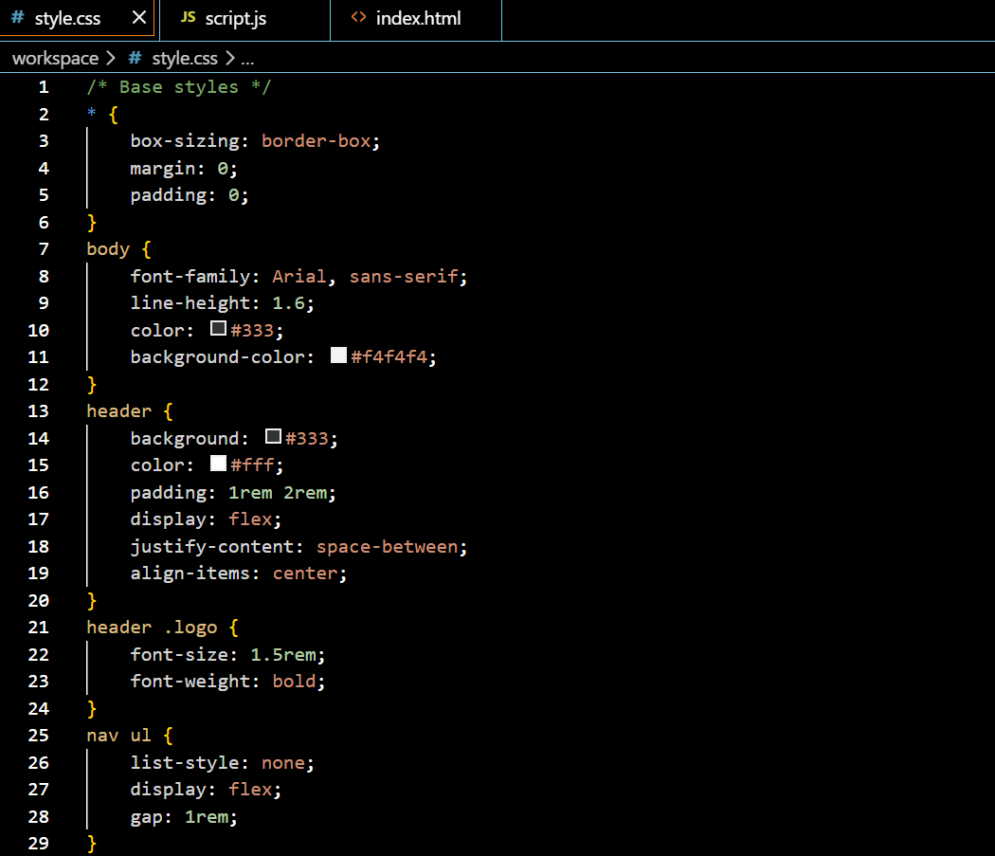

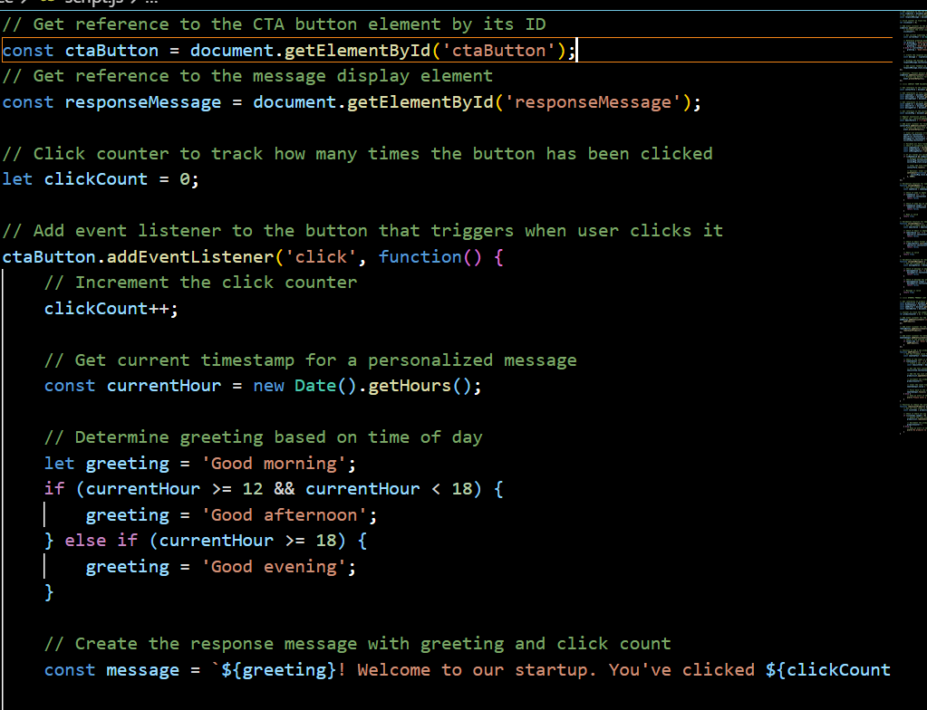
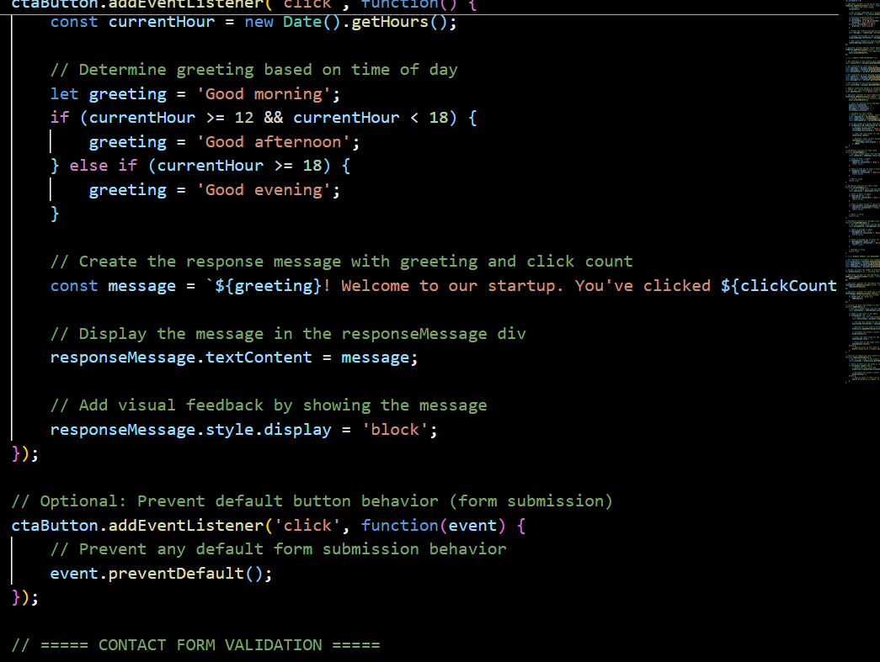
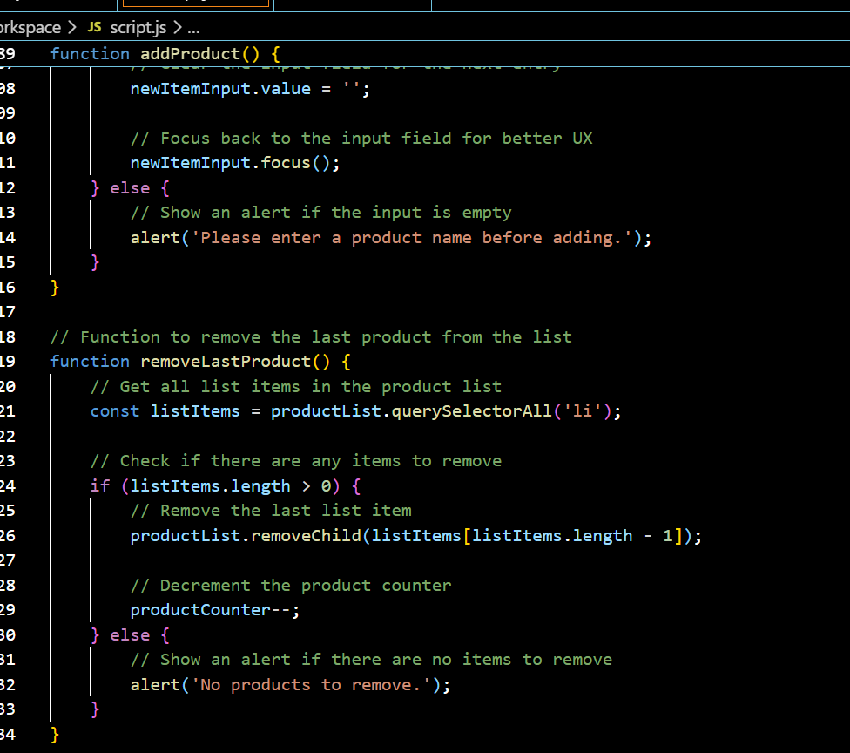
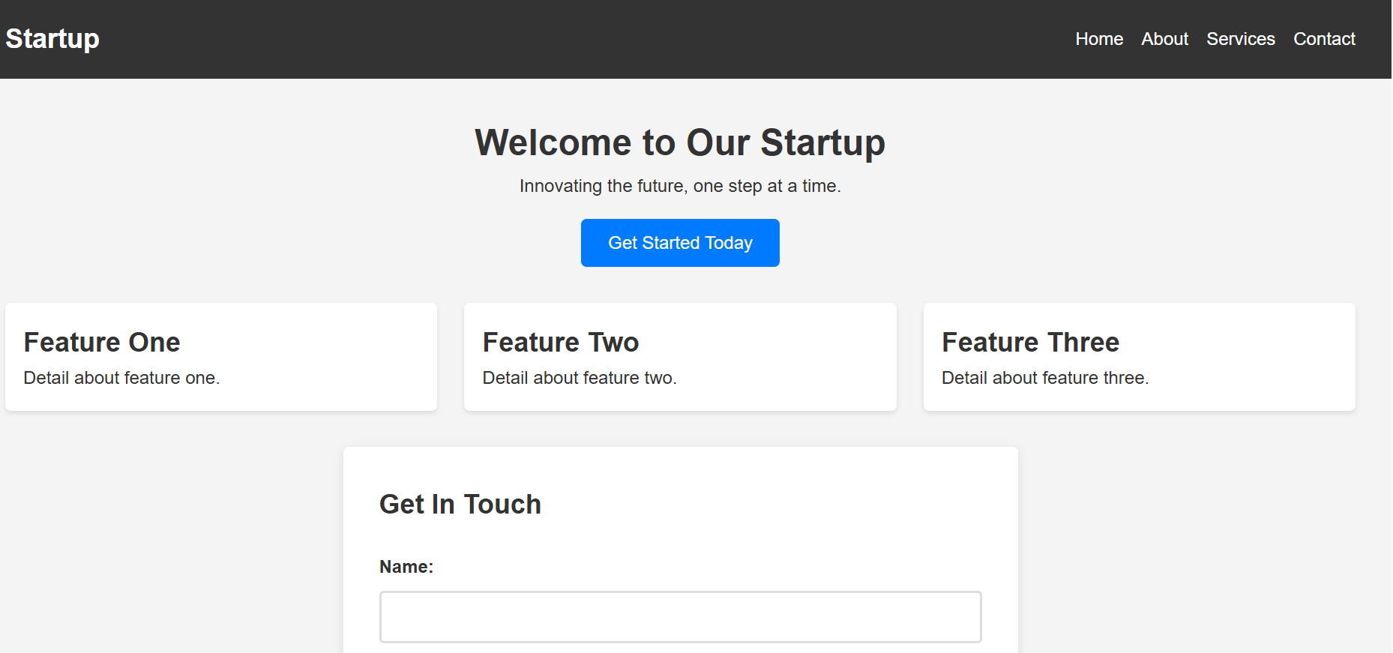

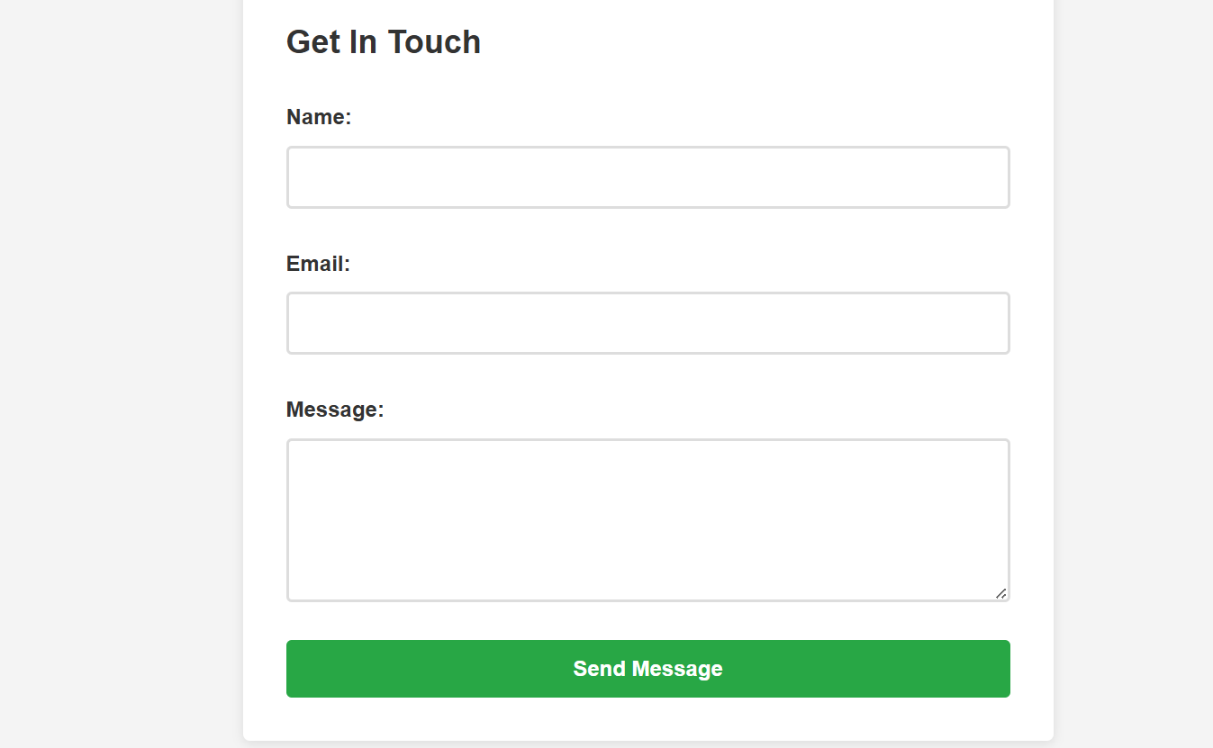
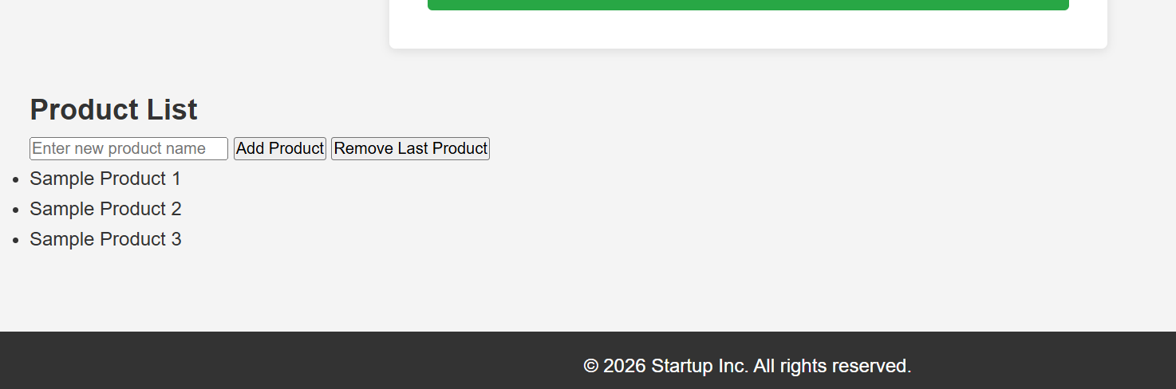

JUSTIFICATION:
This implementation demonstrates how modern web apps update content without annoying page reloads. By manipulating the DOM (Document Object Model) directly through "Add" and "Remove" functions, we create a fluid, desktop-like experience where the interface evolves instantly based on user input.

Task 5: Modal Popup for User Notifications
Scenario
You are building a user notification popup for announcements or alerts
on a website.
Task Description
• Use AI to help generate:
o HTML structure for a modal popup
o CSS styling with a semi-transparent background overlay
o JavaScript to open and close the modal
• Include multiple ways to close the modal (button or overlay
click).
Expected Output
• A web page where:
o Clicking “Open Modal” displays the popup
o Popup overlays the page content clearly
o Modal closes smoothly when instructed

PROMPT:
"Build a modal popup using HTML, CSS, and JS. The modal should have a dark, semi-transparent background that covers the page. Include a button to open it and an 'X' to close it."
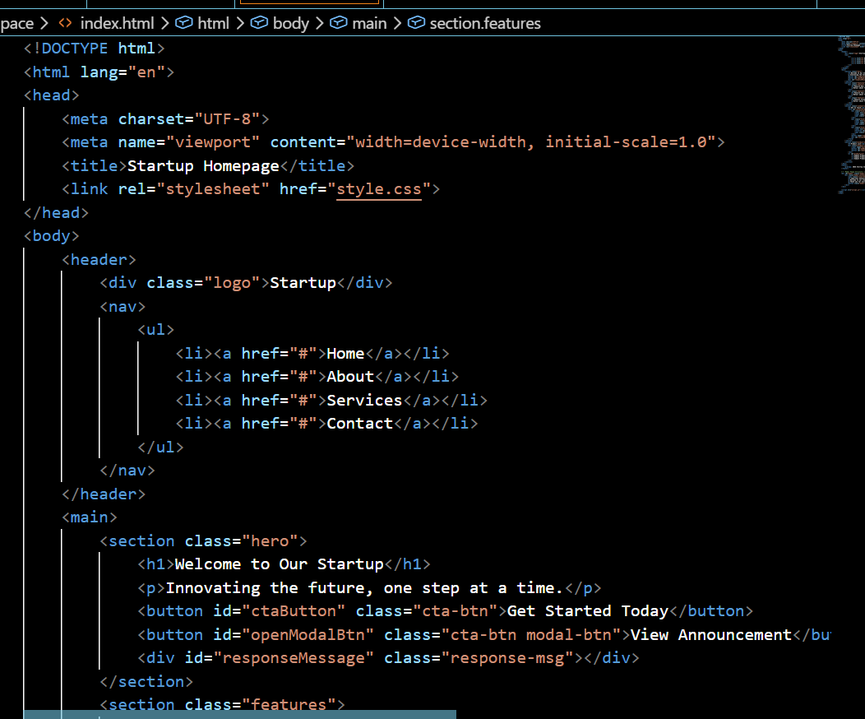
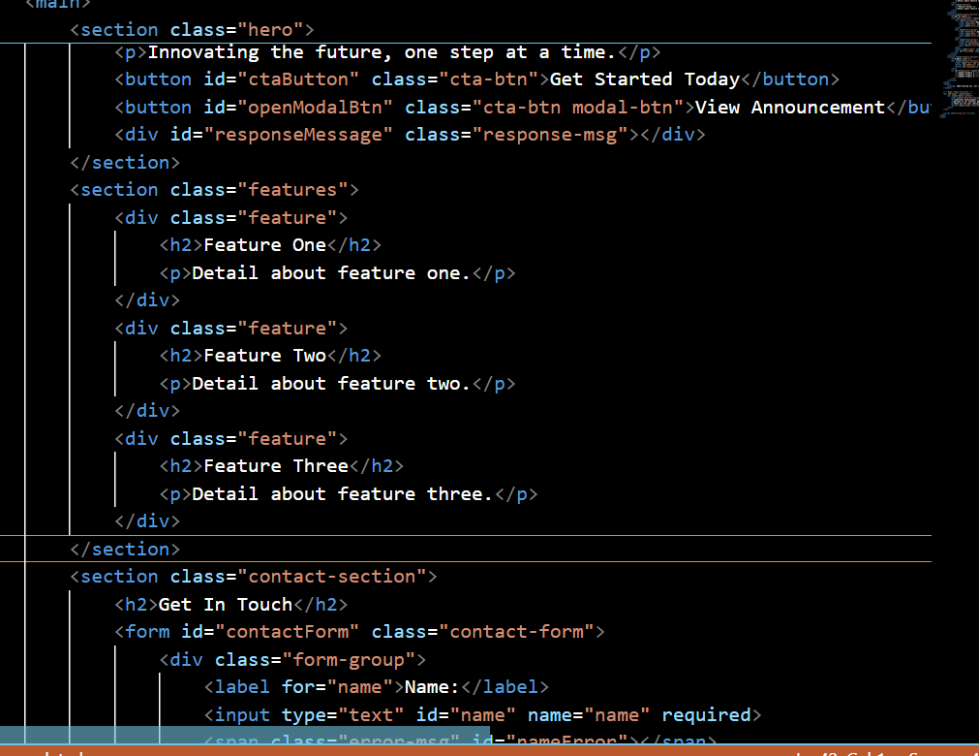
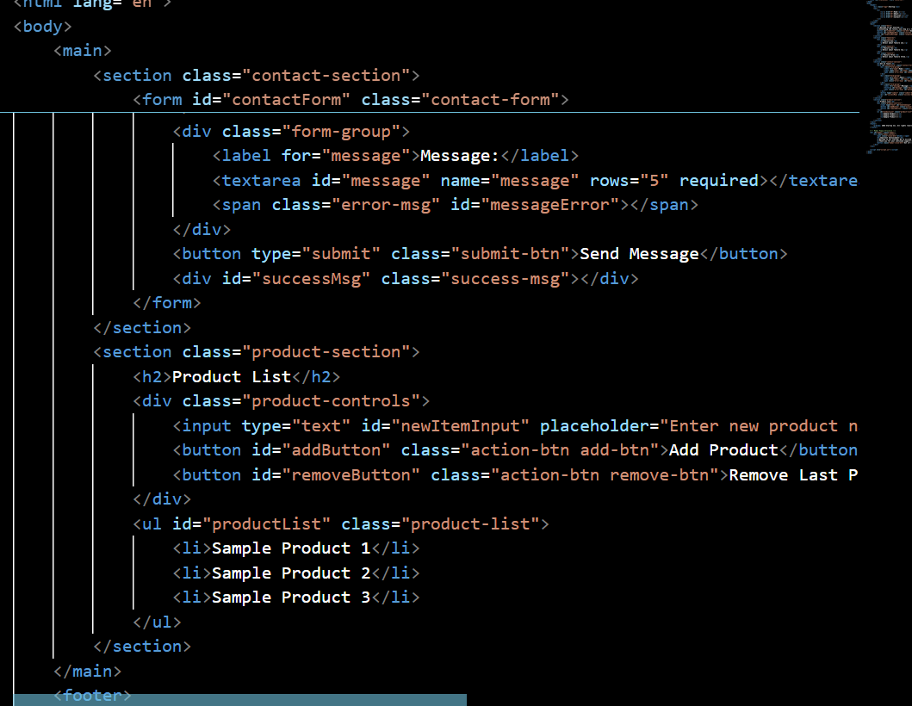
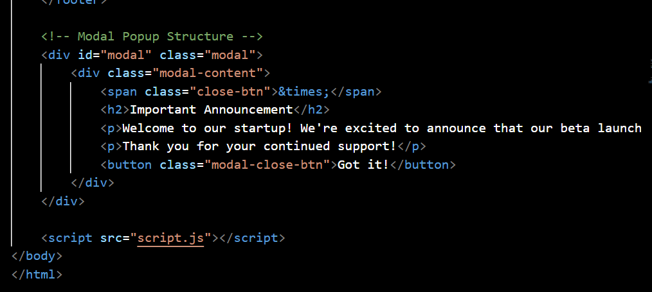
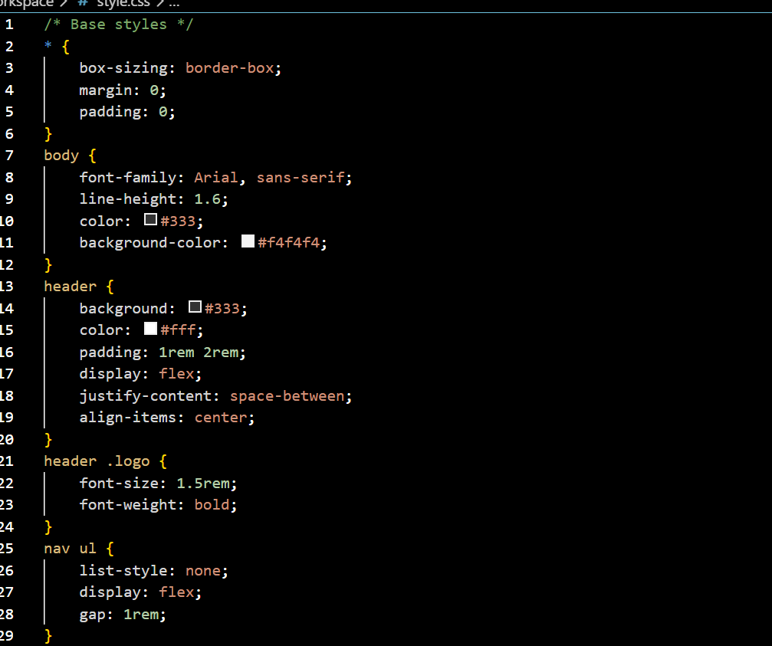
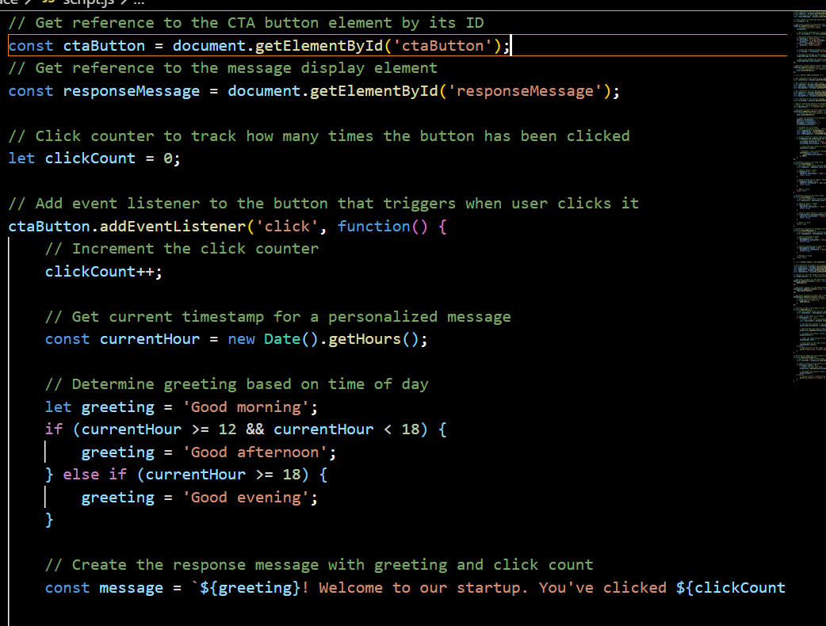
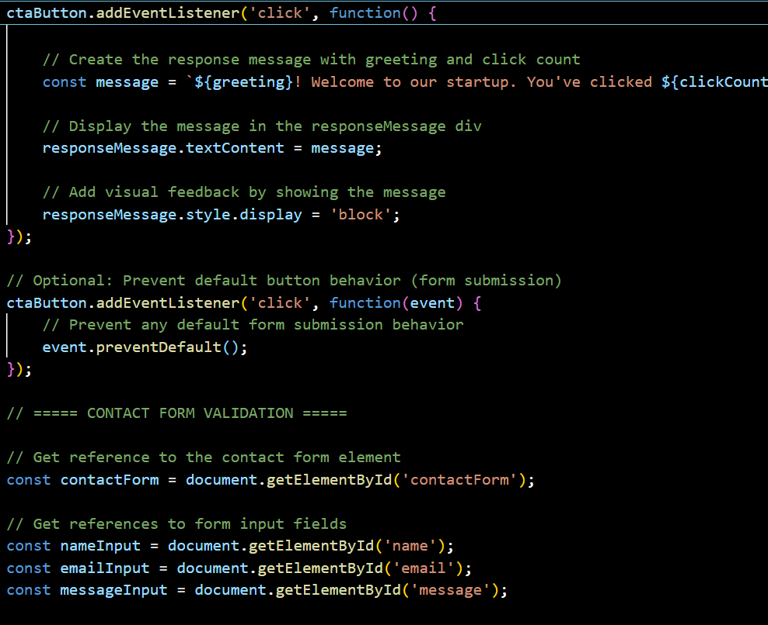
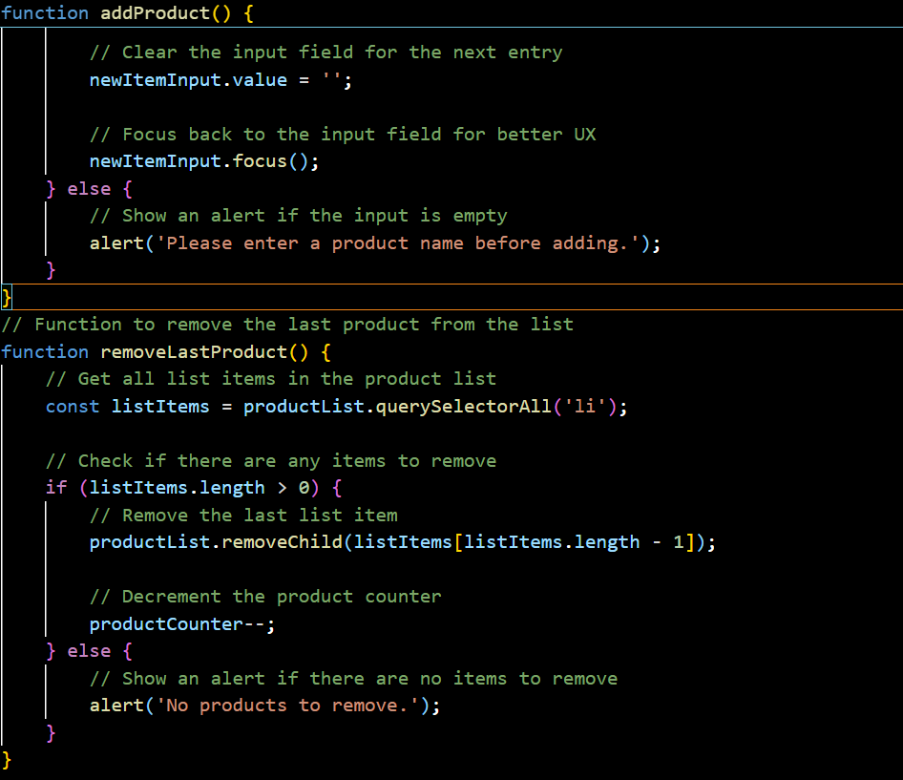

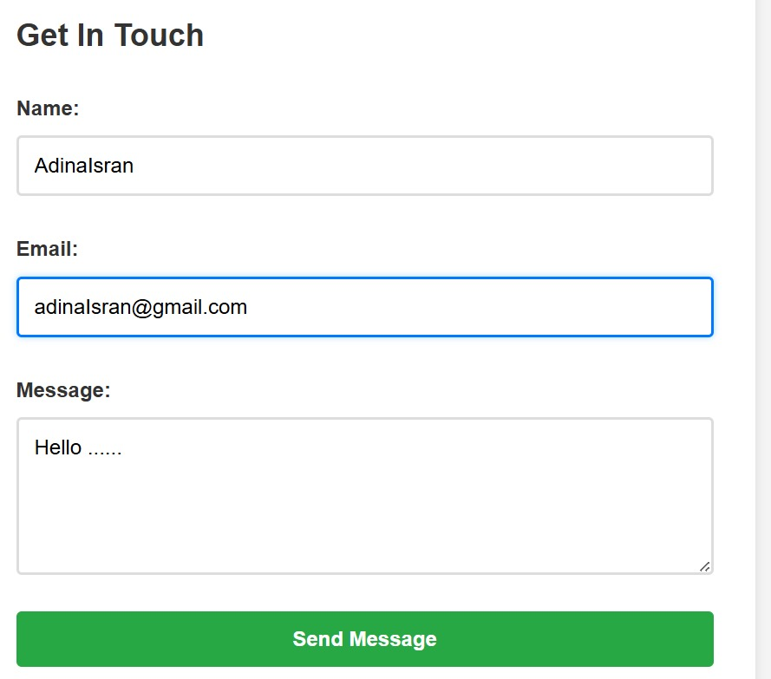

JUSTIFICATION:
The modal serves as a focus-driven UI element designed to capture user attention for important announcements. Using a semi-transparent overlay effectively dims the background noise of the main site, directing the user’s eyes exclusively to the popup content while providing clear exit points for accessibility.

